Manipulating Sound





Electrical and Computer Engineering 100

**Lab 3 Manipulating Sound**

# Overview

The objective of this lab is to introduce you to the analog circuit design using OpAmps. We will study this in the context of manipulating signals by building and testing the following circuits: an amplifier, a low-pass filter, a high-pass filter, and a band-pass filter. Each of these circuits will be tested across a wide range of frequencies to observe their behavior.

### Time vs. Frequency Domain Signals

Before we learn about filters, we first need to understand the difference between the time domain and the frequency domain. Time domain refers to the analysis of a signal with respect to time, whereas frequency domain refers to the analysis of a signal with respect to frequency. The transformation from the time domain to the frequency domain is done through the Fourier Transform. The reason why we sometimes prefer to use the frequency domain is because it can be easier to analyze. For example, sound is usually described in the frequency domain, since processing and shaping of the audio signals are easier described and designed in the frequency domain.

### Abbreviations

**Decibel**: The intensity of sound is often reported in units of decibel (dB). Decibel is given in a logarithmic scale, such that:

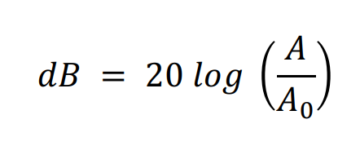

**Cutoff (Corner) Frequency**: The frequency at which energy flowing through a system is beginning to be reduced. Typically, we use -3dB as the cutoff point because it is the point where voltage of the system is decreased from the maximum to half power.

**Hertz**: The SI unit of frequency of vibrations, such as sound. Hertz is the measurement of the number of cycles per second.

# What You Will Need

**Materials:**

• Resistors (1× 10Ω, 1× 680Ω, 2× 220Ω, 3× 1kΩ)

• Potentiometer (1× 10kΩ)

• Capacitors (5× 0.1μF)

• Electrolytic Capacitor (1× 10μF, 1× 100uF, 1× 1000μF)

• Diode (1× 1N4001 or similar)

• Op-Amps (2× LM741, 1×LM386)

• 9V Battery (1×)

• Battery strap/connector (1×)

• Microphone (1×)

• Speaker (1× 8Ω)

• Audio jack (1×)

• Switches (1× SPST, 1×SPDT)

• Breadboard (1×)

• Protoboard (1×)

• Wires (lots!)

**Machinery:**

• Computer / Laptop

• Smart phone

**Software:**

• NI MultiSim 14.2 Education Edition

# Challenge #0: Install MultiSim

In this lab, we will be using a circuit analysis tool called MultiSim. This tool allows us to build, simulate, and analyze various circuits before building the actual circuit with hardware.

Note: The following installation guide is for WINDOWS ONLY.

Install MultiSim (Windows only):

1. You can get a free license from UW COE here:

<https://www.engr.washington.edu/mycoe/computing/software/install_labview>

1. Go to the 'Order' section, click on ‘College of Engineering Software ordering site.’
2. Look for ‘Labview’ and click on ‘Software Request’.
3. Select ‘NI Circuit Design Suite (14.2)’ and then add it to your order.
4. Proceed to check out. **IT SHOULD NOT COST YOU ANY MONEY.**
5. A license key will be emailed to you which you can use to activate MultiSim Education Edition.
6. Download MultiSim 14.2 Education Edition directly from NI here:

<https://www.ni.com/en-us/support/downloads/software-products/download.multisim.html#312060>

1. Use the NI License Manager to activate MultiSim with the license key that was emailed to you.

Other access:

Using Remote desktop:

1. The computer address:
2. Login using your UW ID.

# Challenge #1: Creating an Inverting Amplifier

1. Open MultiSim, go to File-> New-> create a new blank design. Build the inverting amplifier circuit shown below in Figure 1.

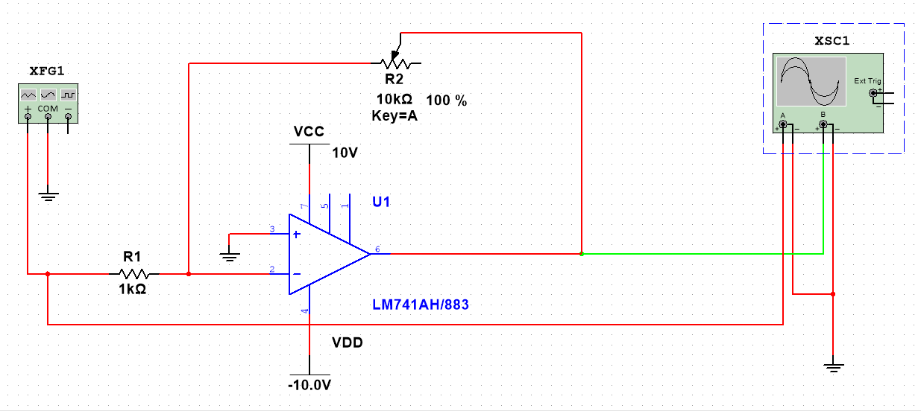

Figure 1. schematic of an Inverting amplifier connected to a function generator and oscilloscope.

**How to find the components:**

Go to “Place” - > “Component”

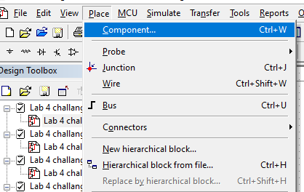

Search the name of the components

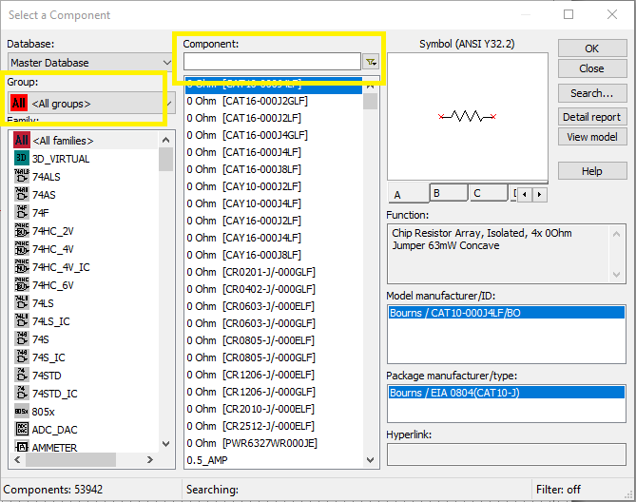

For example:

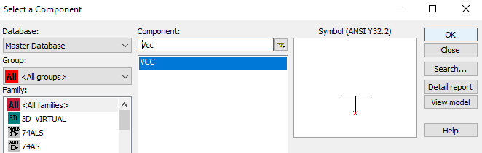

You’ll get the following components. (Power supply: +2V)

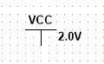

**How to find the function generator and oscilloscope:**

Look to the right toolbar. You can hover over each icon to see which instrument it is.

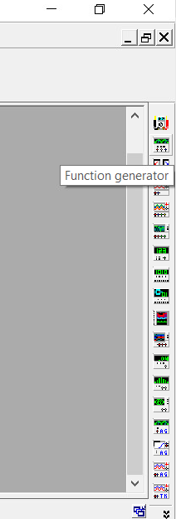

2. Supply an input voltage vin. Using the function generator feature.

Use the following settings:

* Amplitude = 500 mVpp,
* Offset = 0 V
* Frequency = 100 Hz

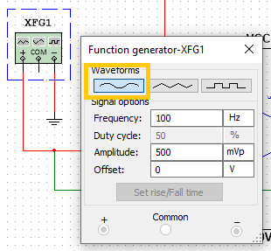

Select the Sinusoidal waveform to generate a sin wave.

3. Observe the input and output voltages using the oscilloscope. Connect the positive terminal of channel 1 to the input and the positive terminal of channel 2 to the output. Make sure to add ground to negative terminals of both channels. (Note: You should see a sine wave at the same frequency at the output. If you do not, check that you have built the circuit properly.)

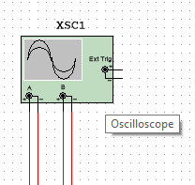

Press the green play button to start the simulation. Double click on the oscilloscope to open the display window below. Once you have opened the display window, you can grab the triangular tab to move the cursor around and get more precise measurements.

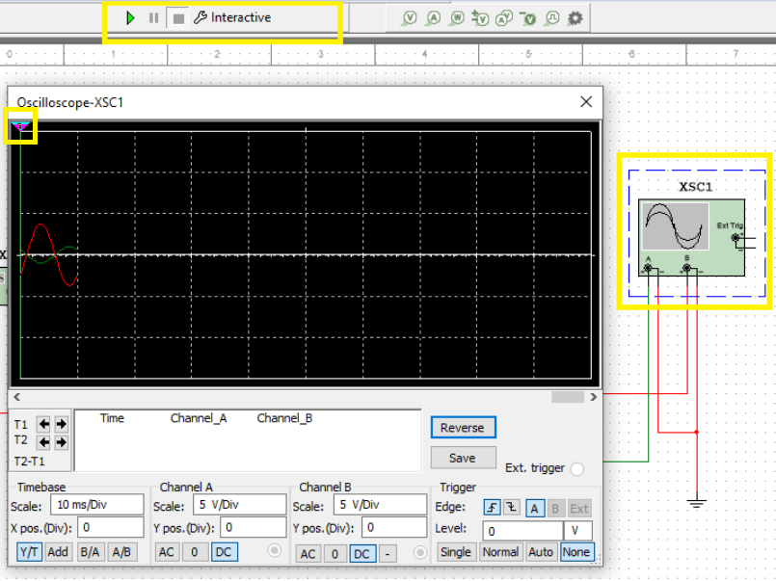

4. In Figure 1, R2 is a component called potentiometer. It acts like a resistor, but we can adjust its resistance value. For example, if the slider is at 50%, the value of the potentiometer is now 10 kOhm * 50% = 5 kOhm. Adjust the potentiometer’s slider to change its value and see how it impacts the output voltage value.

We can define the following function to characterize the inverting amplifier:

where is the gain.

Experiment with different resistance values for the potentiometer, then define A as a function of R1 and R2 for this inverting amplifier circuit. (Hint: Pay attention to the peaks and troughs.)

5. Change the function generator to output a square wave (with the same amplitude and frequency). What does the output look like?

**How to change the function generator to output square wave:**

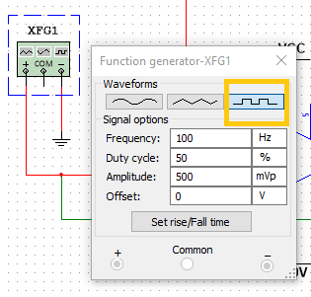

# Challenge #2: Active Low-Pass Filter (LPF)

1. Create a new blank design. Then, build the active low-pass filter shown below in Figure 7.

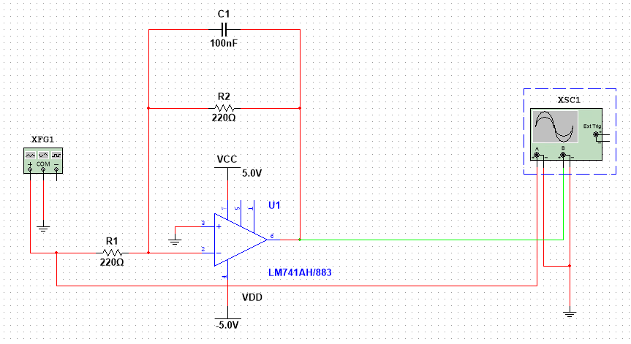

Figure 7. Schematic of a low-pass filter connected to a function generator and oscilloscope.

2. Supply an input voltage vin. using the function generator.

Use the following settings:

* Waveform = Sine
* Amplitude = 500mVpp
* Offset = 0V
* Frequency = 100Hz

We will use AC sweep to run signals at various frequencies across the filter.

To use AC Sweep, we need to place on-page connectors as the data source we want to read for AC sweep. The On-page connectors can be places and connected as below:

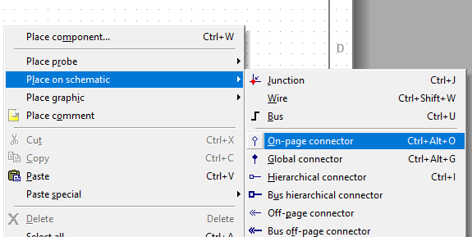

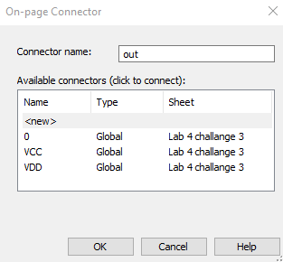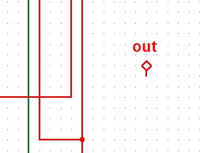

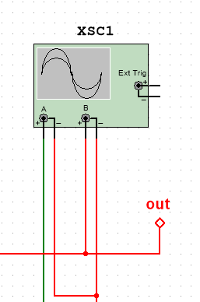

Now, open up the Analyzes and simulation page by clicking on the tool bar simulate > Analyzes and simulation:

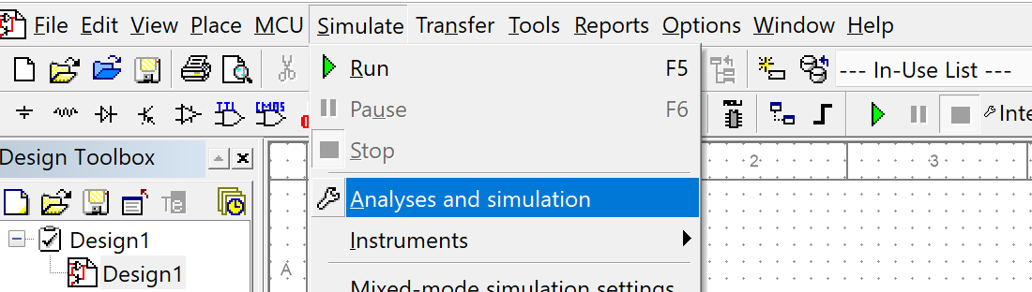

Or by clicking on the Analyzes and simulation shortcut in the box:

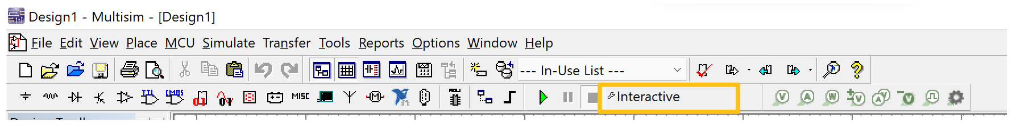

Select AC Sweep:

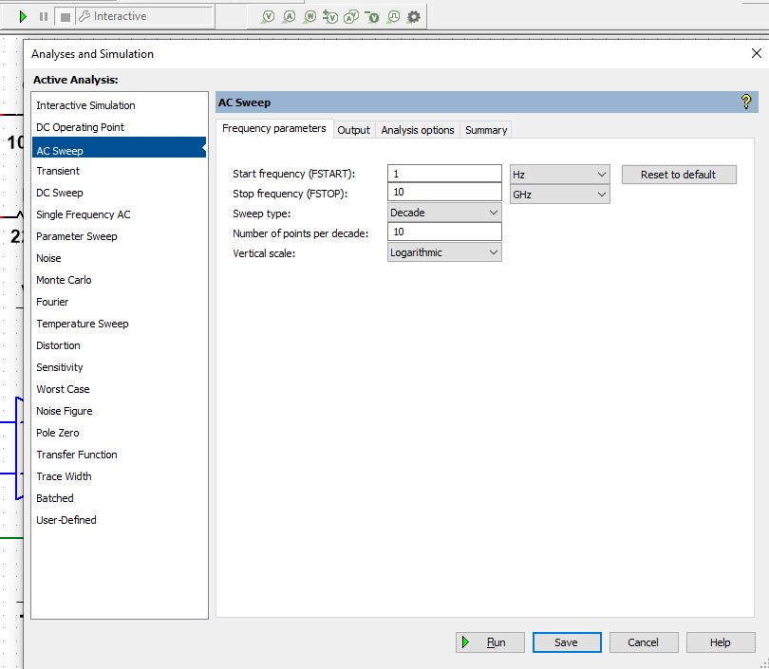

Go to ‘Output’ tab.

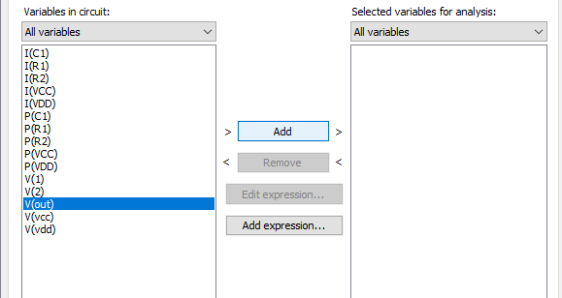

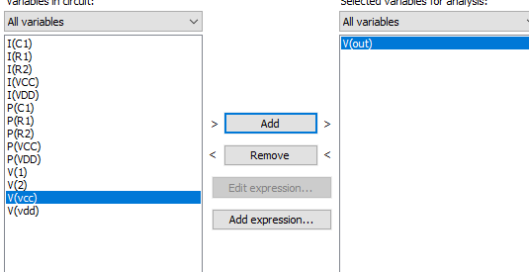

Go back to the ‘Frequency parameters’ tab. Change FSTOP to 40 kHz. Change vertical scale to ‘Decibel’.

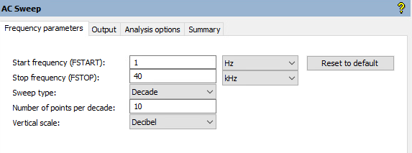

Press ‘Run. Your output should look similar to this. Click on the ‘Show cursors’ button indicated by box 1 below. Two cursors, box 2 and 3, should appear, and you can grab the triangular tab to drag them around to get more precise measurements.

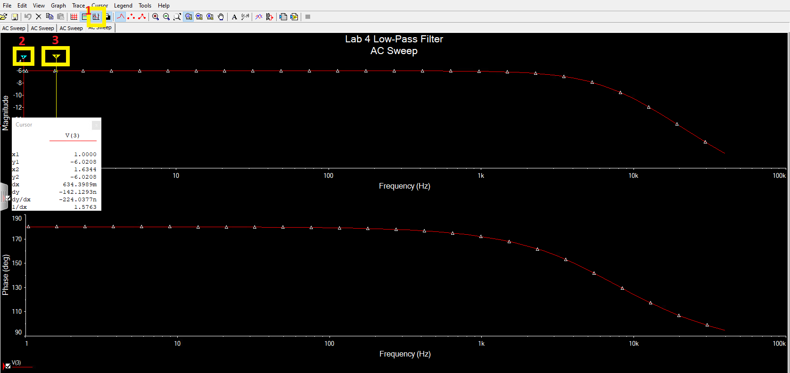

3. Now that we have finished the set-up, let’s explore a little bit what we are looking at.

First, what are those two plots above? Together, those two plots are called the Bode plot. The upper plot plots magnitude vs. frequency, and the lower plot plots phase angle vs. frequency. For our class, we will ignore the lower plot.

You may have noticed that the magnitude plot uses Decibel (dB) for its vertical scale. There is a direct relationship between magnitude and dB, but we will keep it simple here and avoid overwhelming everyone with math. In short,

* At 0 dB, magnitude is 1.
* At < 0 dB, magnitude is between 0 and 1.
* At > 0 dB, magnitude is greater than 1.

Now, let’s look back at the magnitude plot you have obtained earlier. Notice how as frequency increases, the magnitude remains relatively constant until it suddenly falls? Briefly explain why this circuit is called a “low-pass filter”.

4. Let’s now find the cutoff frequency. What is the cutoff frequency? Simply put, **the cutoff frequency is the frequency at which the signal can no longer pass through the filter**. In this section, we have built an active low pass filter, which is one type of low pass filter. In an ideal low pass filter, the magnitude would go straight to zero at the cutoff frequency and remain at zero for higher frequency. However, as you have seen, in our simulation, the magnitude decreases over time instead of going straight to zero.

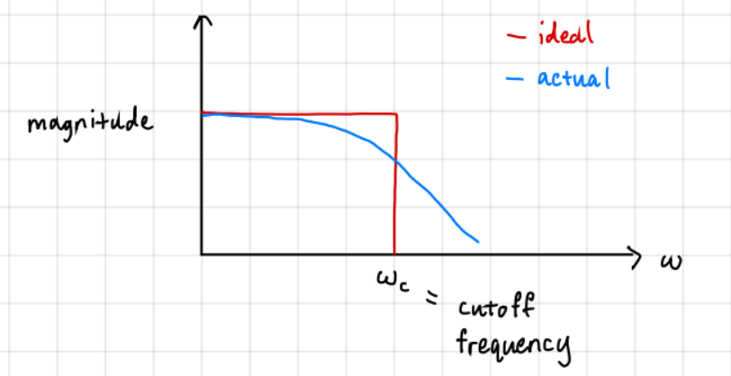

Thus, for our actual circuit, we define the cutoff frequency as the frequency at which the maximum magnitude has decreased by about 70%.

One particularly nice benefit of using dB scale is that it is easier to find the cutoff frequency. When using the dB scale, the cutoff frequency is located at where the maximum magnitude in dB has decreased by 3 dB. For example, if we measure the maximum magnitude to be 0 dB, then the cutoff frequency is located at where the magnitude = 0 - 3 = -3 dB.

Find the cutoff frequency of our active low pass filter circuit. You can use the cursors to get more detailed measurements from the plot.

NOTE: Do NOT take the circuit apart. The circuit will be used in challenge #4.

# Challenge #3: Active High-Pass Filter (HPF)

1. Create a new blank design in MultiSim. Then, build the circuit shown in Figure 8 below.

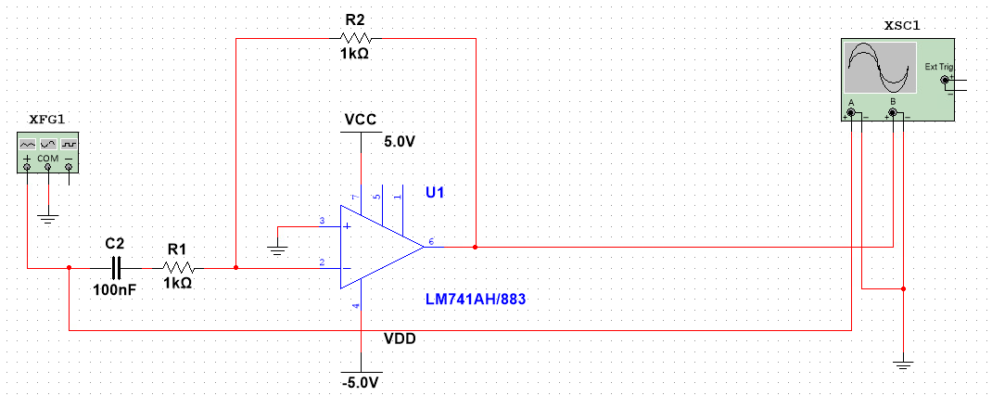

Figure 8. Schematic of a high-pass filter connected to a function generator and oscilloscope.

2. Supply an input voltage vin. using the function generator. Use the following settings: Amplitude = 500mVpp, Offset = 0V, Waveform = Sine, Frequency = 100Hz.

Obtain the Bode plot using the ‘AC Sweep’ feature just like in Challenge #2. Make sure the vertical scale is in Decibel.

3. Observe the magnitude plot. Why is this circuit called a high-pass filter?

4. Find the cutoff frequency of this high-pass filter.

NOTE: Do NOT take the circuit apart. The circuit will be used in challenge #4.

# Challenge #4: Band-Pass Filter (BPF)

Next, we will build a band-pass filter which can be made by cascading a high-pass filter followed by a low-pass filter.

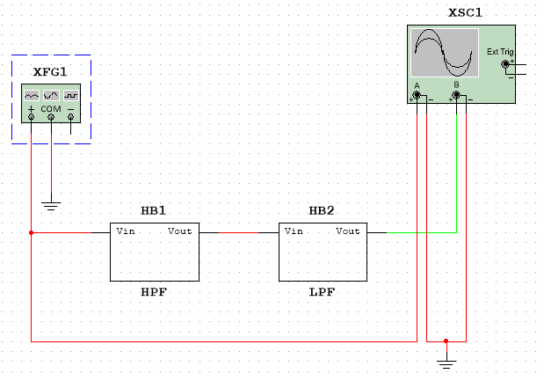

Figure 9. Block diagram for band-pass filter.

1. Create a new blank design. Figure 9 only shows a high-level block diagram of a band-pass filter. You will need to use both the HPF and LPF you have previously built to build the actual circuit for the band-pass filter. (Hint: The output of one filter is fed into the input of the other filter. Also, you can select, copy, and paste circuits.)

2. Supply an input voltage vin. using the function generator. Use the following settings: Amplitude = 500mVpp, Offset = 0V, Waveform = Sine, Frequency = 1kHz.

3. How many cutoff frequencies are there on the magnitude plot. What are their values?

4. Why is this circuit called a band-pass filter?

# Challenge #5: Audio Amplifier

Now that we understand a bit more on how signals flow through analog circuits and various ways to manipulate them, we want to build our own portable audio amplifier and speaker system that we can plug into any music playing device. We will setup and solder a commonly used circuit design to make this happen using capacitors, resistors, and a new Op-Amp.

First, we will start to build a circuit for a microphone:

5.1.1. Build the microphone circuit shown above in Figure 1 in the Multisim. The breadboard implementation of this circuit is provided in Figure 2.

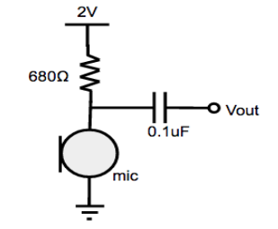

Figure 1. Schematic of microphone circuit.

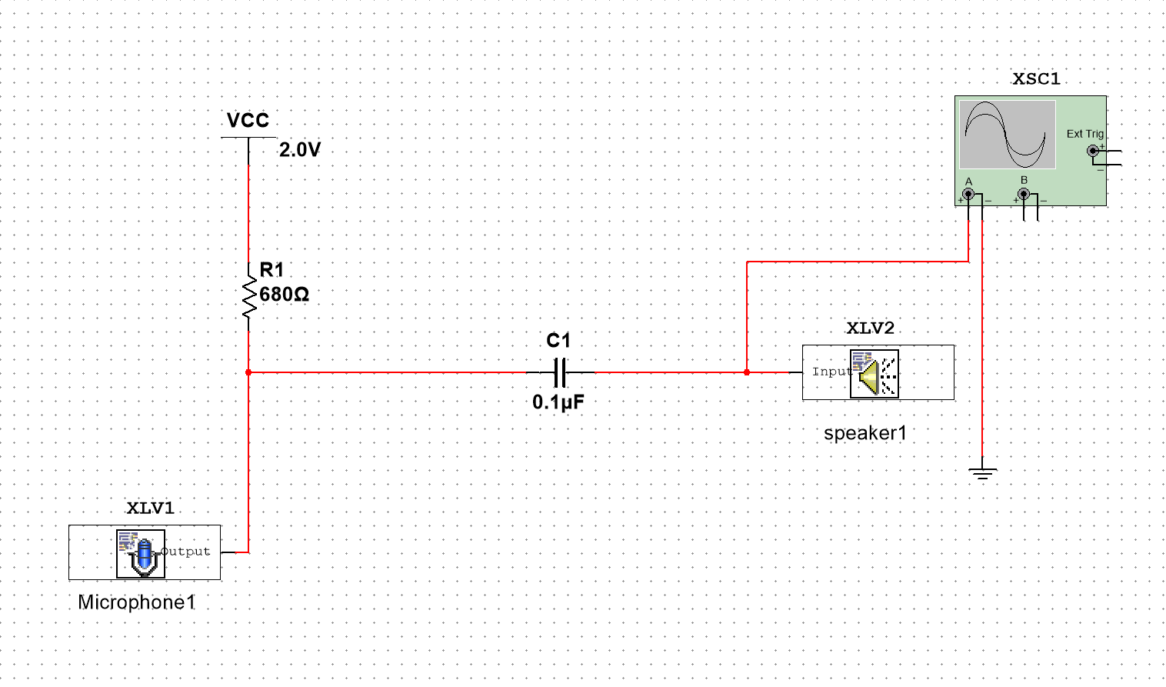

Figure 1. Schematic of microphone circuit.

The microphone and speaker can be found in toolbar-> simulate -> Instruments-> LabVIEW instruments like below:

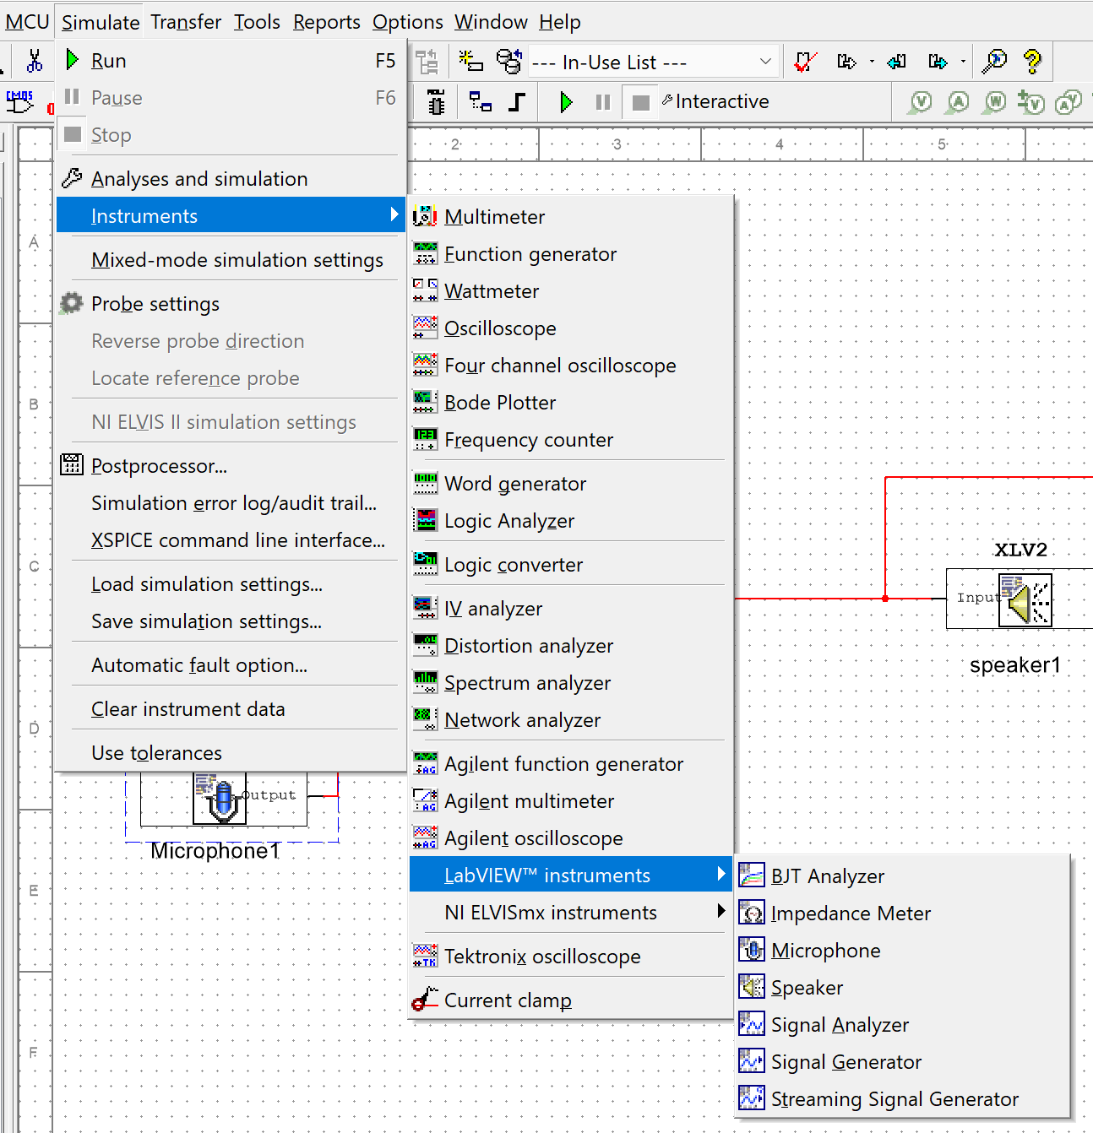

The setting of the microphone looks like below:

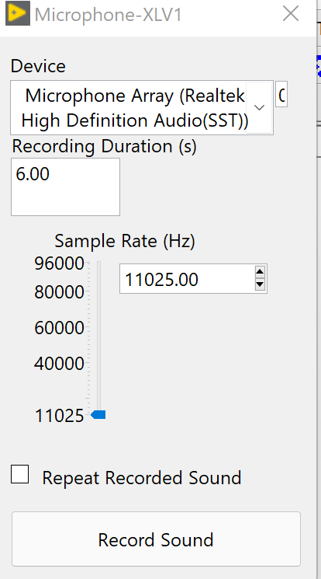

The setting of speaker look like this:

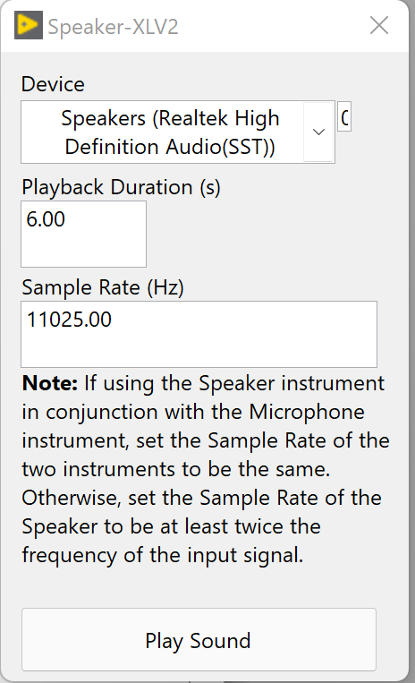

5.1.2. After setting up the parameters like above, go to the microphone window, to play a music using your own phone to play a piece of music(longer than the record duration) you like and hit Record Sound button:

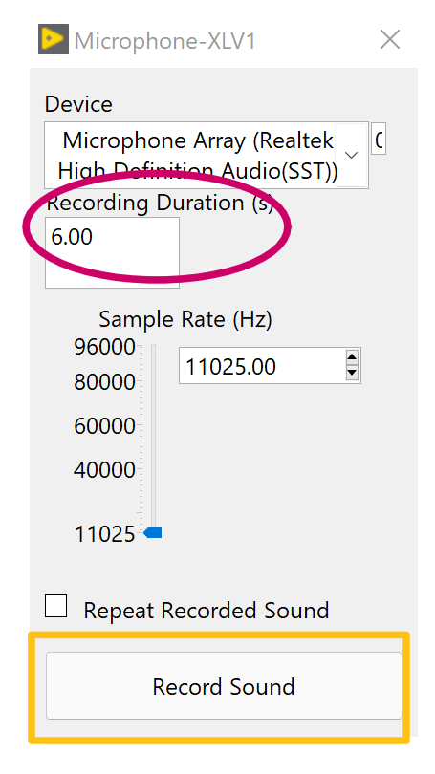

5.1.3 The Record Sound would automatically turn grey when recording and back to clickable when finished.

5.1.4 Click the Play button to start circuit simulate. 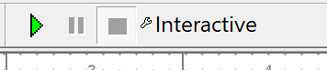

5.1.5Double click oscilloscope to see the wave output.

Note: The wave may be a straight line in the first few seconds.

The bottom right corner shows which second the system has currently calculated. Remember, 6 seconds of music file is a lot of thing to calculate. The calculation process can take as long as 6 minutes. 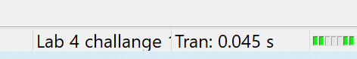

5.1.6 After the 6 second file has been fully calculated, hit stop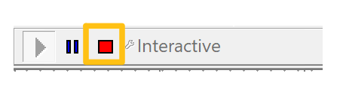, then double click the speaker window and hit play sound. 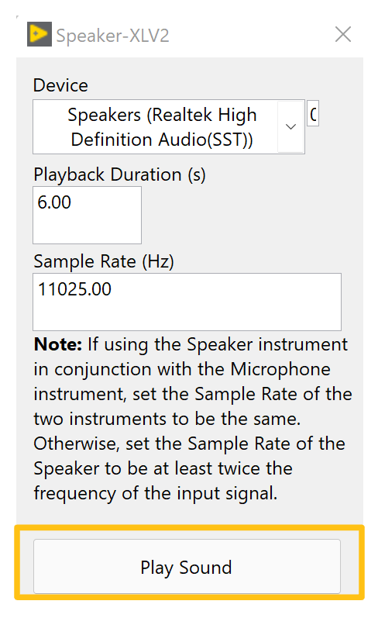

5.1.7 If you can hear the thing you just recorded, congratulations, you have a properly set up microphone system now. You will use the same microphone for the next section.

There are many different types of Op-Amps available for various applications. LM 741 is a general-purpose Op-Amp and can be used in most applications, even though it may not be the best option all the time. In this part of the lab, we will be using LM386, a low voltage amplifier made specific for audio amplification. For more detailed information on the LM386. Please refer to Appendix 1 and the LM386 datasheet.

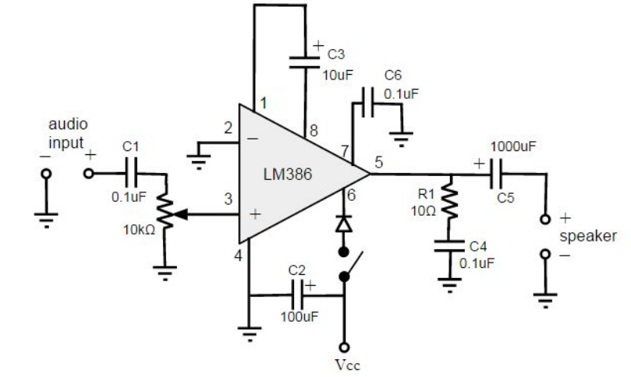

Figure 11. Schematic of speaker amplifier using LM386.

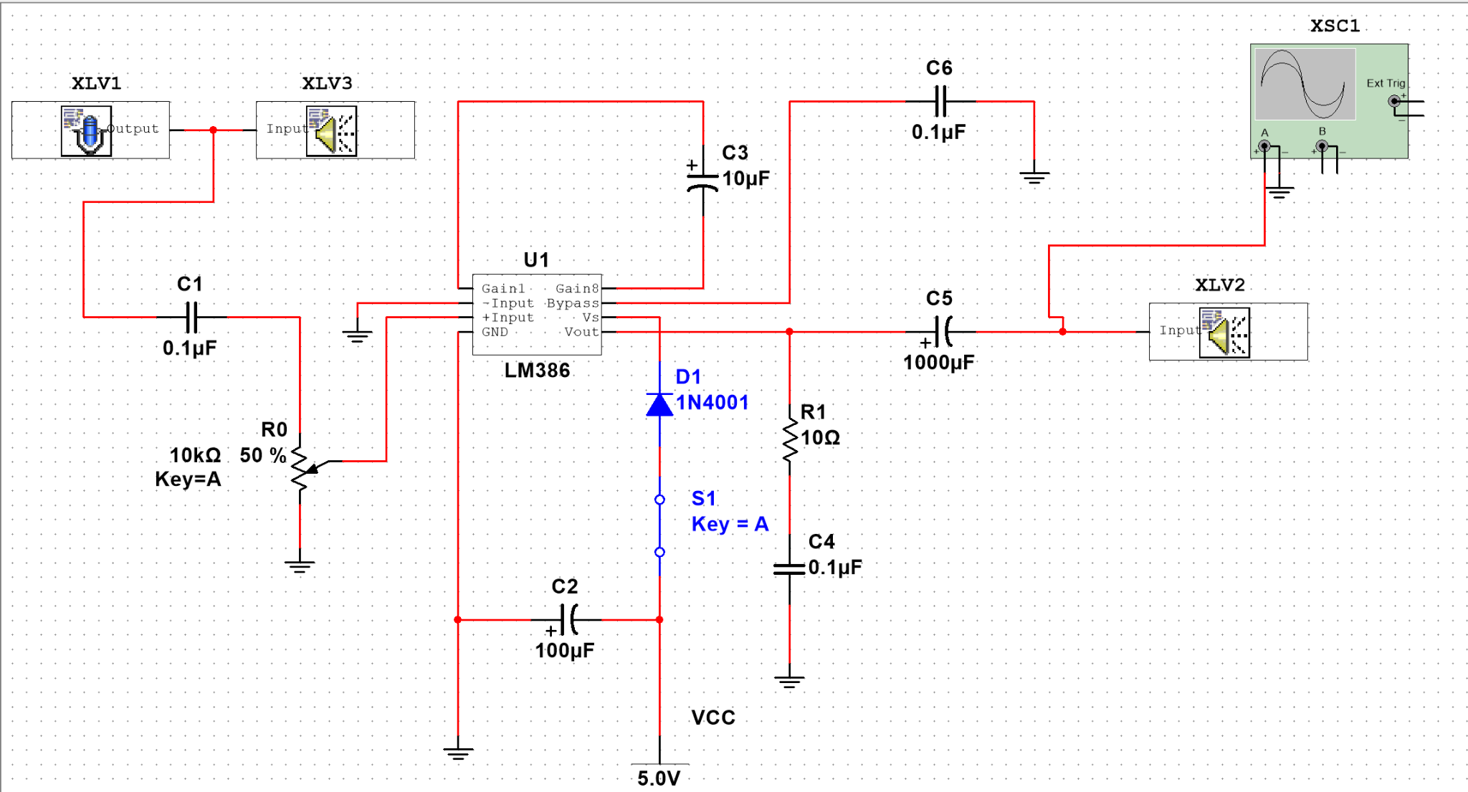

5.2.1 Using the Multisim file provided, build the circuit according to the given schematic in Figure 11. In this circuit, C3 sets the gain of the amplifier to 200. C6 acts as a bypass capacitor to prevent degradation of gain, and possible instabilities. C2 connected between power and ground helps maintain the supply voltage. The potentiometer controls the amplitude of the input signal, adjusting the volume of the sound. C1 and C5 remove DC offset from the input and output signals respectively. R1 and C4 form a Zobel network when connected in parallel with the speaker, removing high-frequency noise.

5. 2. 2. Add a diode between VCC and pin 6 for safety reasons. If you by accident switched the polarity of the power source, the diode will not allow the current to flow.

5.2.3. Hook a function generator to the circuit, sweep the frequency to plot the frequency response of the circuit. What is the lower cutoff frequency? What is the upper cutoff frequency? What is the gain of this amplifier?

5.2.4. Click into the microphone and start the recording.Use 10s duration and 11025 Hz.

5.2.5 Start the simulation. Note: like last section, the 10s recording could take 10 minutes to simulate and calculate.

5.2.6 After 10 seconds sound has been fully simulated, play the sound of speaker XLV2 and XLV3, compare the difference between the outputs.

5.2.7. Now that you know your speaker is working. Enjoy your music!

# Optional Challenge: Add-on microphone input

Now that you have a working audio amplifier, you can add an electret microphone to the circuit and have the amplifier circuit take the signals from the microphone as the input.

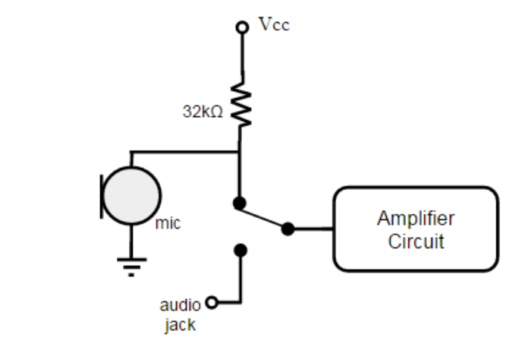

Figure 13. Allows switching between microphone and audio jack.

1. Connect the electret microphone to the input of the amplifier from challenge #6. Remember to power the microphone and add a resistor to ensure that no more than 0.5mA of current is flowing through the electret microphone.

2. Double check your connections, then test the circuit by speaking into the microphone.

3. Once the circuit is working, you can add a SPDT (Single Pole Double Throw) switch that allows you to switch between the microphone input and the audio jack input.

# Other Challenges: Audio Related Projects

There are a wide variety of audio-related projects available online. Here are some possible online projects that you can try out:

1. Tone Control Circuit<http://www.instructables.com/id/Active-tone-control-circuit/>

2. Guitar Distortion Petal<http://www.instructables.com/id/Make-an-easy-guitar-distortion-pedal-STEP-BY-STEP/>

3. Overdrive Pedal<http://www.instructables.com/id/Overdrive-Pedal/?ALLSTEPS>

4. Design a 3-D Printed Speaker Case

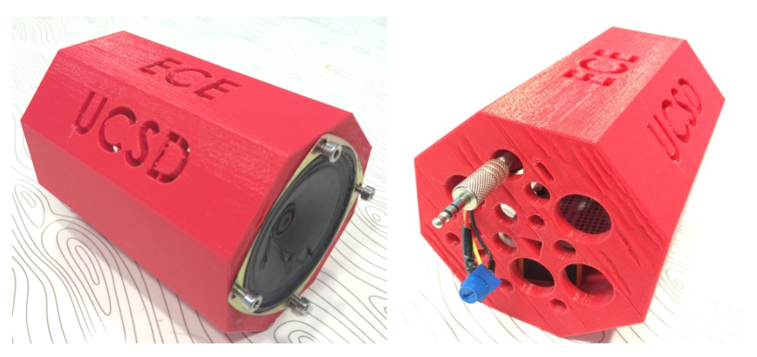

# 

# Appendix I - Resources

This is a really good resource for understanding how sound signals are processed! Go here to learn more about filters:<http://beausievers.com/synth/synthbasics/>

This is the datasheet for Low Voltage Audio Power Amplifier LM741:<http://www.ti.com/lit/ds/symlink/lm741.pdf>

This is the datasheet for Low Voltage Audio Power Amplifier LM386:<http://www.ti.com/lit/ds/symlink/lm386.pdf>

This article is a good resource for understanding how to select an appropriate op amp for different applications:<http://www.ti.com/lit/an/slyt213/slyt213.pdf>